Banding Machine Standard:
The banding machine can be added as a hand labor department operation.

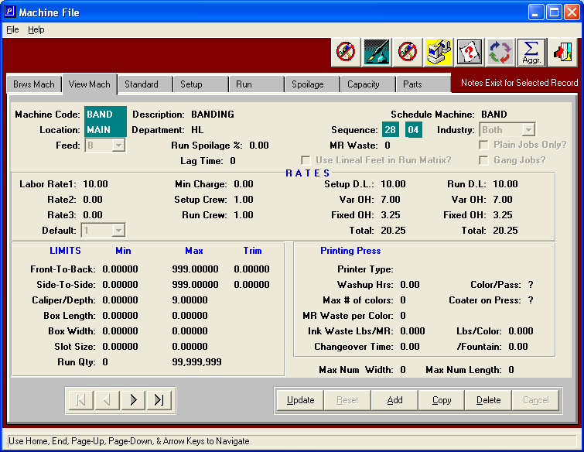

On the “Standard” tab input code 98 – Unitizing Formula for the run X and Y axis values.
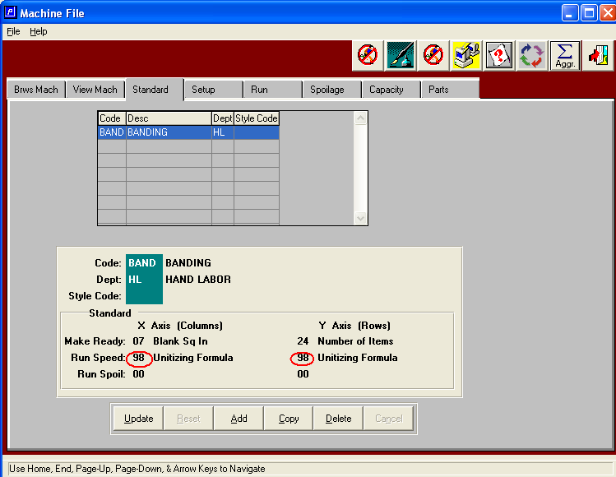

On the “Run” tab you will need to input a value that represents a banding speed per pallet. The banding / unitzing run time is based on a speed per pallet. If the run standard has 120 then it is taking .5 minutes to band one pallet.(120 are banded per hour, or 2 are banded per minute, or one is banded per ½ minute). The system calculates this as 1/120 = .00833 hours (or 30 seconds). If the estimate calls for 10 pallets the run time will be 5 minutes.

